Daniel Blenman

4/12/2020

GRA1750

Prof. Borreo

Design Brief

**Introduction**

1. **Font:** 
   1. *Calibri (N/A)*
      1. *Color: #000000*
      2. *Size: 12px*
   2. *Roboto(Thin)*
      1. *Color:#5C5C5C*
      2. *Size:15px, 30px*
   3. *Roboto(Black)*
      1. *Color: 30px*
2. **Background:**
   1. *Background Image: Wooden Background*
3. **Margin, Padding, Hovers:**
   1. 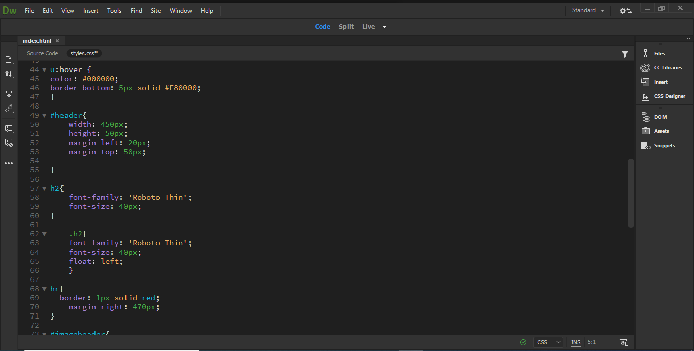
   2. 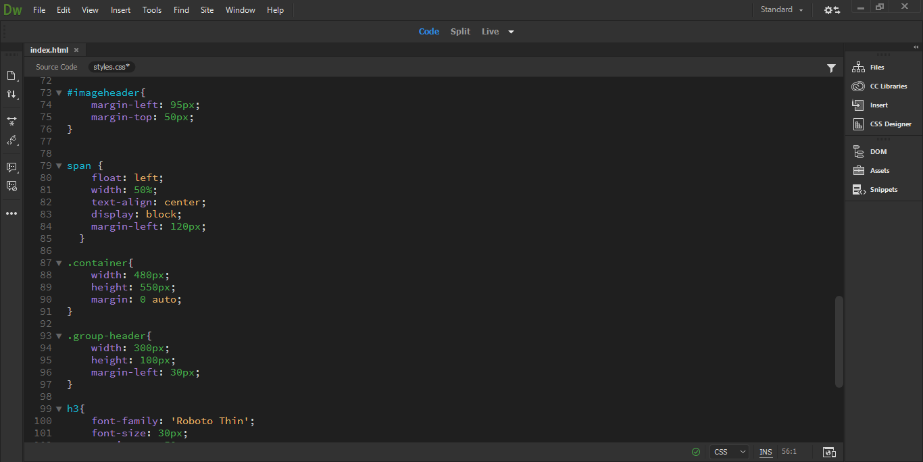
4. **Images, Image size**
   1. 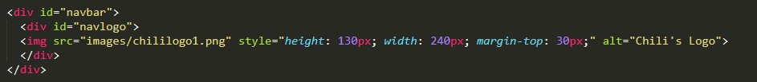
   2. 
   3. 
   4. 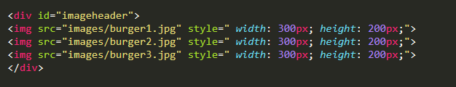
5. **Menu**
   1. ***Appetizer***
      1. *Triple Dipper (256 Cal.)*
         1. *Price: $24.99*
         2. *Description: Why choose one when you can choose three? Select three appetizers and enjoy! Served with dipping sauces.*
      2. *Southern Egg Rolls(213 Cal.)*
         1. *Price: $14.99*
         2. *Description:These aren’t your ordinary eggrolls. Crispy flour tortillas, chicken, black beans, corn, jalapeño Jack cheese, red peppers, spinach. Served with avocado-ranch.*
      3. *Loaded Boneless Wings(324 Cal.)*
         1. *Price:$19.99*
         2. *Description: Smothered in white queso, shredded cheese, bacon, green onions. Served with house-made ranch.*
      4. *Classic Nachos with Beef(211 Cal.)*
         1. *Price:$10.99*
         2. *Description: Beef, shredded cheese, black beans, jalapeños, Skillet Queso with beef. Served with pico & sour cream.*
   2. **Ribs and Steak**
      1. *Classic Sirloin(402 Cal.)*
         1. *Price:$24.99*
         2. *Description: Marbled, thick-cut steak topped with garlic butter. Served with loaded mashed potatoes, steamed broccoli.*
      2. *Classic Ribs(413 Cal.)*
         1. *Price: $20.99*
         2. *Description: Seasoned & topped with garlic butter. Served with loaded mashed potatoes, steamed broccoli.*
      3. *Classic Ribs 20 oz. (424 Cal.)*
         1. *Price: $29.99*
         2. *Description: Seasoned & topped with garlic butter. Served with loaded mashed potatoes, steamed broccoli.*
      4. *Ancho Ribs 20 oz. (474 Cal.)*
         1. *Price:$34.99*
         2. *Description: Seared chile-rubbed Atlantic ribs, spicy citrus-chile sauce, cilantro, queso fresco. Served with Mexican rice & steamed broccoli.*
   3. ***Burgers***
      1. *The Boss Burger(266 Cal.)*
         1. *Price:$16.99*
         2. *Description:The burger all other burgers report to. Smoked brisket, tender rib meat, jalapeno-cheddar smoked sausage, bacon and cheddar with lettuce, tomato, House BBQ and house-made ranch. We. Dare. You.*
      2. *Mushroom Swiss Burger*(294 Cal.)*
         1. *Price:$19.99*
         2. *There’s so mush-room in our hearts for this one. Topped with sauteed onions, mushrooms, Swiss, lettuce, tomato & garlic aioli.*
      3. *Just Bacon Burger(311 Cal.)*
         1. *Price:$19.99*
         2. *Description:Don’t let the name fool you. This classic is layered with slices of bacon, cheddar, pickles, lettuce, red onion, tomato & garlic aioli.*
6. **Restaurant Info/History**
   1. **Chili's** was inspired by a chili cookoff held in Terlingua, Texas, in 1967. It was attended by a young entrepreneur named Larry Lavine, who was inspired to develop his own chili recipe and in 1975 opened the first **Chili's** in Dallas. The location of this restaurant is locally on *18976 NW 57th Ave.*